LPARDesign Extended

**USER’S GUIDE**

**Version V02-T06**

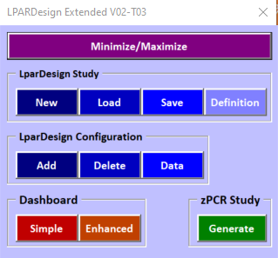

**Doc : LPARDesign-Extended-V02-T06_AMTD_UserGuide.docx**

**© 2024 AMTD**

**Updated: June 17th, 2024**

**Alain Maneville & Thierry Déléris**

Table Of Content

1. Introduction to LPARDesign Extended Tool 2

2. DISCLAIMER OF WARRANTIES 3

3. HOW TO GET THE PRODUCT – IMPORTANT NOTICE: 4

3.1 Important Information 4

3.2 From Github 4

4. CHANGES IN THIS RELEASE. 5

4.1 What’s new in V02-T06 5

4.1.1 Support for zPCR 9.6.5 5

4.2 What’s new in V02-T05 5

4.2.1 Support for zPCR 9.6.4 5

4.3 What’s new in V02-T04 5

4.3.1 Support for zPCR 9.6.2 5

4.4 What’s new in V02-T03 5

4.4.1 Support for the IBM z16 A02 & AGZ and zPCR 9.6 5

4.5 What’s new in V02-T02 5

4.5.1 Support for the IBM z16 A01 and zPCR 9.5 5

4.6 What’s new in V01-T02 5

4.6.1 Support for zPCR 9.4a 5

4.7 What’s new in V01-T01 5

4.7.1 Support for LPARDesign V11-T01 5

4.7.2 Support for zPCR 9.4 5

5. THE NAVIGATION AND ACTION BAR. 6

5.1 BAR Functions. 6

6. LPARDesign Extended Workflow – Creating a Study and loading files. 7

6.1 STEP-1: Create a New Study (initial usage) 7

6.2 STEP-2: LOAD LPARDesign Configuration Files 7

6.3 STEP-3: Refine LPARDesign Configuration Files with further information for zPCR. 8

6.4 Setting the LPARDesign Extend Study Id 9

7. LPARDesign Extended Workflow – Comparing Configurations. 10

7.1 Important Notes on the comparison process: 10

7.2 STEP-1: Reviewing the loaded configurations 10

7.3 STEP-2: Comparing Configurations – Enhanced Dashboard 10

7.4 STEP-3 – Compare the configurations by LPAR Names and PU Types (GCP, zIIP, IFL, ICF) 11

7.5 STEP-4 – The Sort Rules. 11

8. Other Features. 13

8.1 Simple Dashboard. 13

8.2 zPCR study generation 13

8.2.1 zPCR study generation workflow. 13

8.3 The DATA button 13

8.4 Housekeeping 14

# Introduction to LPARDesign Extended Tool

This document explains how to use the LPARDesign Extended Tool.

This tool helps in comparing various LPAR configurations that have been created by the LPARDesign Tool.

It provides visual comparisons and can create a zPCR study including these various LPAR configurations.

Here is a visual synthesis about the **LparDesign Tool** functions:

* *It let us work on a single PR/SM configuration to analyze, optimize, and study it*

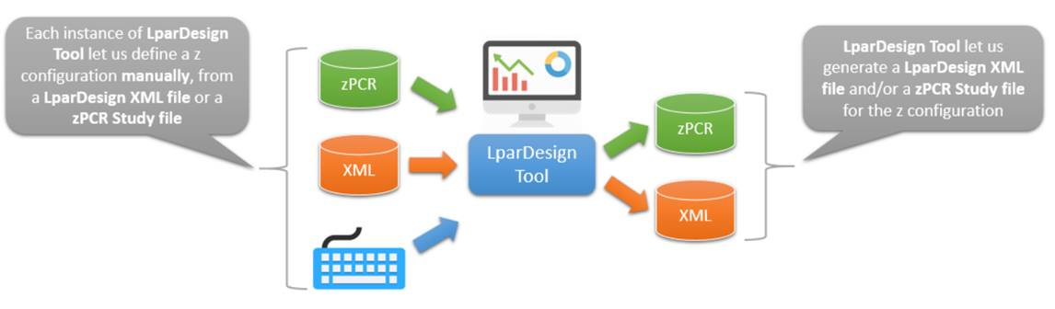

And here is a visual synthesis about **LparDesign Extended Tool** functions:

* *LparDesign Extended Tool is an add-on to LparDesign Tool*
* *It let us work with multiple PR/SM configurations produced thanks to the loading of the corresponding LparDesign Tool XML output files*
* *And so we could build some comparison dashboards between two PR/SM configurations or simply investigate from one PR/SM configuration to another*

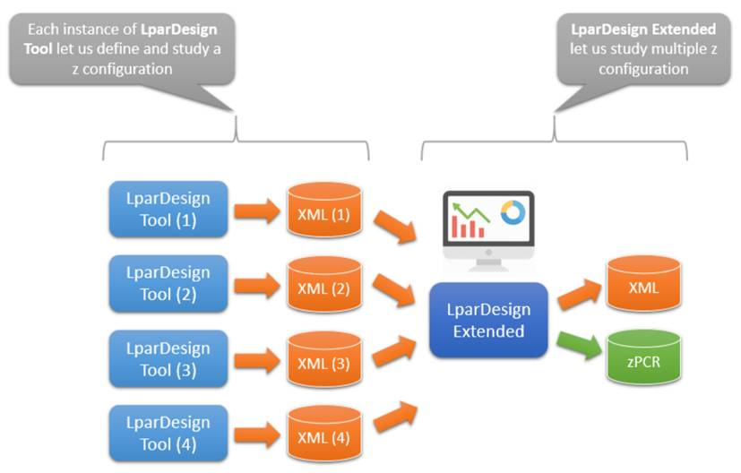

# DISCLAIMER OF WARRANTIES

***The following [enclosed] macro is sample code created by Thierry Deleris and Alain Maneville.***

***This sample macro is provided to you solely for assisting you in the PR/SM LPAR ® and HiperDispatch® Configuration.***

***The code is provided "AS IS", without warranty of any kind. Thierry Deleris and Alain Maneville shall not be liable for any damages arising out of your use of such sample code, even if you have been advised of the possibility of such damage***

***Support: Support will be provided on a "best effort" basis. Send the spreadsheet for an analysis to thierry.deleris@orange.fr, and/or to*** [***a.maneville@gmail.com***](mailto:a.maneville@gmail.com)

# HOW TO GET THE PRODUCT – IMPORTANT NOTICE:

## Important Information

The tool will only be available from GitHub.

## From Github

The product is available on the GitHub Web Site at the URL:

<https://github.com/ThDeleris/z-OS-LPARDesign>

You will get this page :

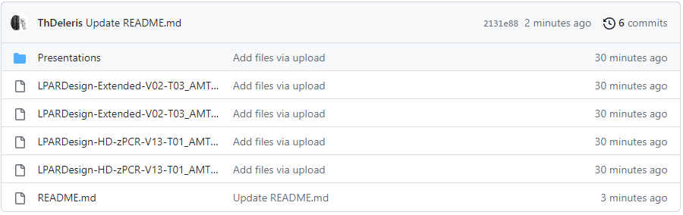

Then, Click on the LPAR Design Hyperlink for the spreadsheet **AND** the User’s Guide to download them.

# CHANGES IN THIS RELEASE.

## What’s new in V02-T06

### Support for zPCR 9.6.5

## What’s new in V02-T05

### Support for zPCR 9.6.4

## What’s new in V02-T04

### Support for zPCR 9.6.2

## What’s new in V02-T03

### Support for the IBM z16 A02 & AGZ and zPCR 9.6

## What’s new in V02-T02

### Support for the IBM z16 A01 and zPCR 9.5

## What’s new in V01-T02

Minor bug correction when building the zPCR Study

### Support for zPCR 9.4a

## What’s new in V01-T01

The V01-T01 is the first version of the product.

### Support for LPARDesign V11-T01

The configuration .xml files created by LPARDesign V11-T01 are supported in this tool.

### Support for zPCR 9.4

# THE NAVIGATION AND ACTION BAR.

To make things simpler and easier, a navigation and action BAR is provided.

It is available when you open the spreadsheet and stays until you close it.

You can move it anywhere in the worksheets (you will do that when first opening the product).

## BAR Functions.

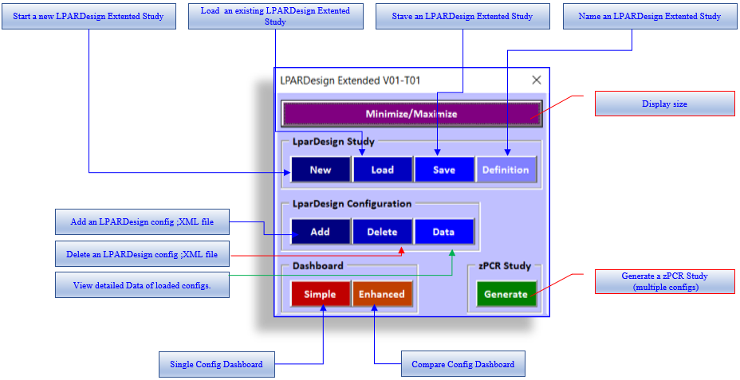

Sliding the mouse pointer to one of the icons shows its function:

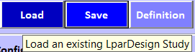

# LPARDesign Extended Workflow – Creating a Study and loading files.

## STEP-1: Create a New Study (initial usage)

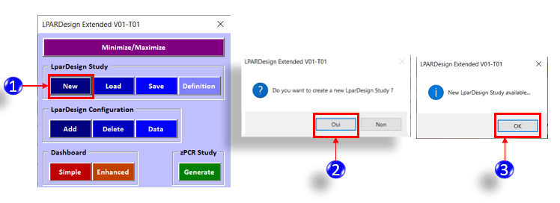

This will create a fresh LPARDesign Extended Study.

Now you must LOAD LPARDesign configuration files (.xml Files) to further compare them.

## STEP-2: LOAD LPARDesign Configuration Files

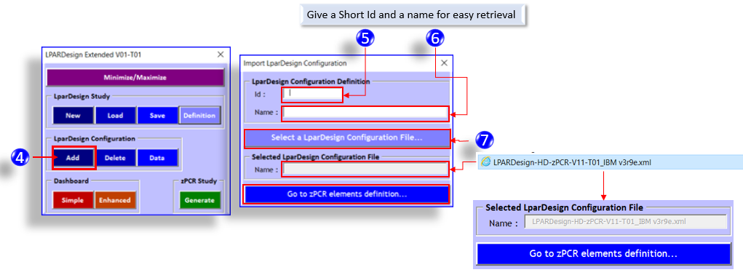

## STEP-3: Refine LPARDesign Configuration Files with further information for zPCR.

For example, you might need to specify what is the **Max**nnn value for this z15-T01 machine. **This is for zPCR configuration to be accurate**.

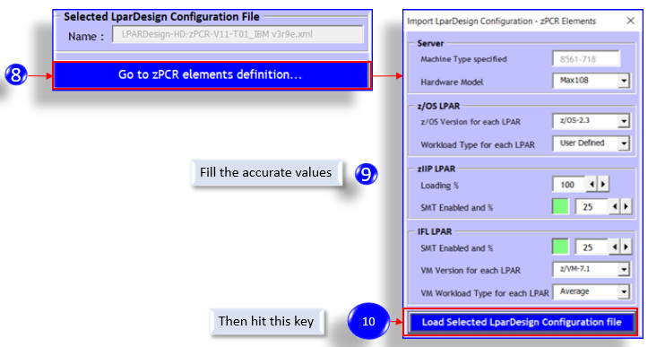

At that time you have Loaded this LPARDesign xml file, you will receive a confirmation PopUp and you can see you loaded configuration in the main worksheet:

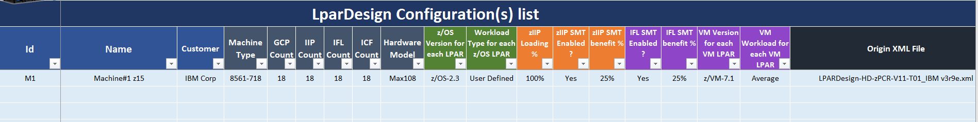

The Id and the Name are those that you have set in :

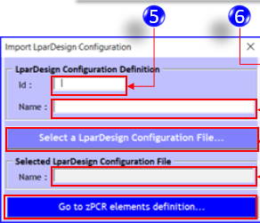

You will do that for every LPARDesign configuration .xml file that you want to further compare

## Setting the LPARDesign Extend Study Id

At any time, you can set or change the “name” of the study:



# LPARDesign Extended Workflow – Comparing Configurations.

This is the main objective of the Tool.

In this situation, you have loaded various LPARDesign configuration .xml files and you want to compare these configurations.

## Important Notes on the comparison process:

You will be able to compare **By LPAR Name** – which is the key of the comparison process.

For example, if you compare two machines where all the LPAR Names are not present, the LPARDesign Extended Tool will search only the LPAR Names that are present in both machines.

## STEP-1: Reviewing the loaded configurations

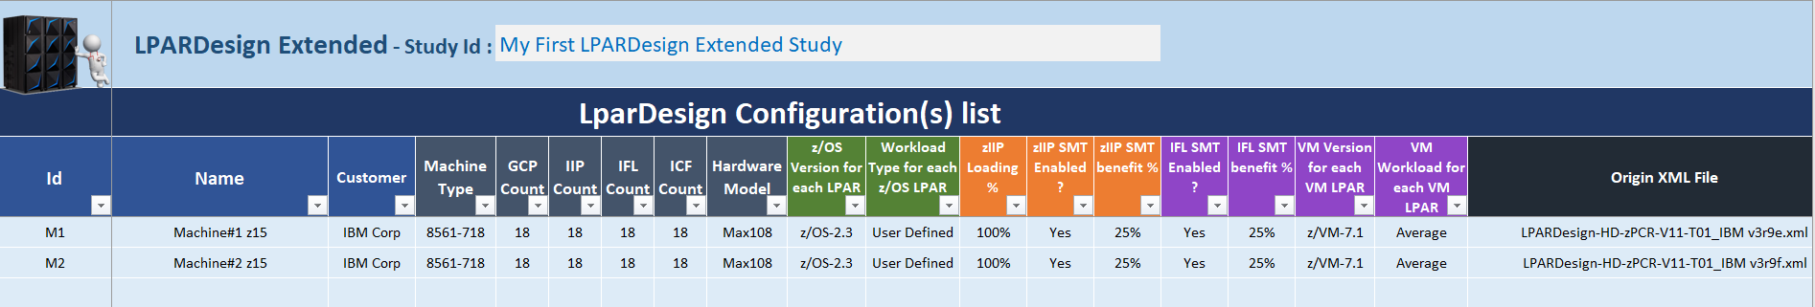

In the main worksheet you have all the previously loaded configurations

So, you need to choose which of them you want to compare.

## STEP-2: Comparing Configurations – Enhanced Dashboard

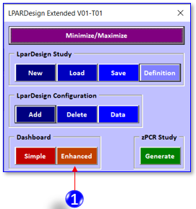

After pressing the Enhanced Dashboard button, you will get the main worksheet panel where you can choose the configurations (Id and PU Type) to compare:

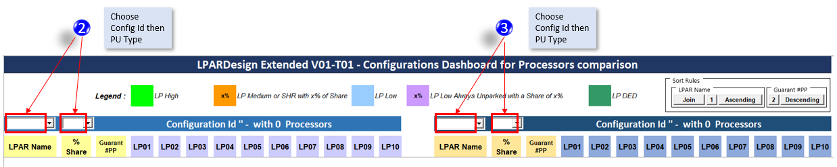

## STEP-3 – Compare the configurations by LPAR Names and PU Types (GCP, zIIP, IFL, ICF)

In this example, we compare the Dashboards from the M1 and M2 configurations for the GCP PU.

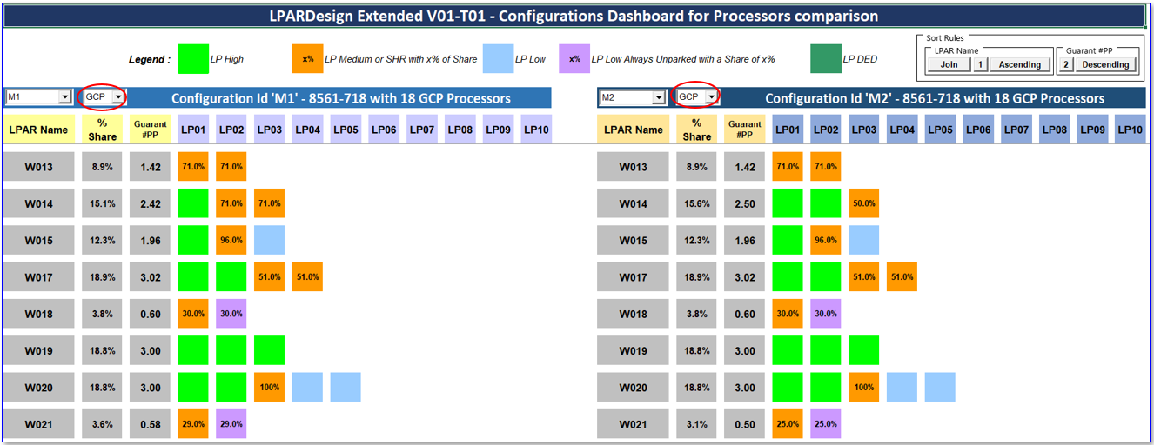

We can easily determine that the W014 LPAR has one more VH in configuration M2:

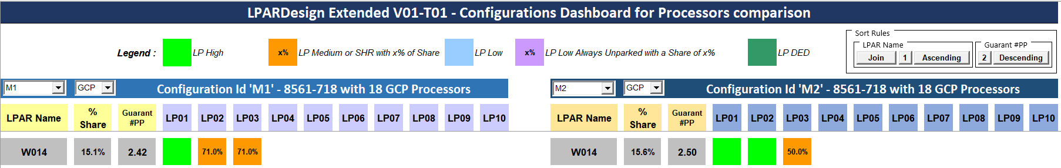

Others PU types can be compared too – Just scroll the PU Type button list:

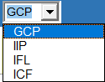 in each configurations.

Note: To better analyze the configurations, scroll to have the LPAR name you want to check just below the column titles.

## STEP-4 – The Sort Rules.

In the **Enhanced Dashboard** you could use the **Sort Rules Box** for your study:

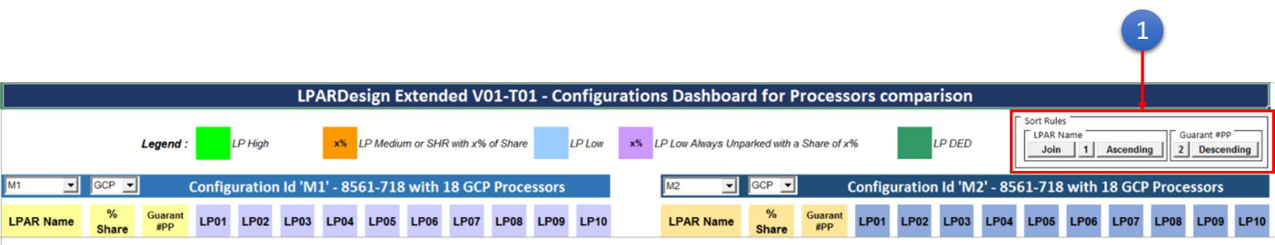

In details here is the box :

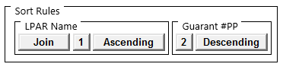

The sort rules are divided between **LPAR Name** and **Guaranteed number of Physical Processor** (« Guarant #PP ») keys.

* In the **LPAR Name** part of the Box, the first button is the **Join/No Join** button
  + When **Join** is selected this lets you build a Dashboard where the lines of the two configurations are joined on the LPAR Name.

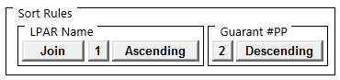

* + - In this case the **LPAR Name** will necessary be the first order Key and the **Guarant #PP** the second Key
  + When **No Join** is selected there is no join on the **LPAR Name** between the lines of the two configurations selected in the Dashboard.

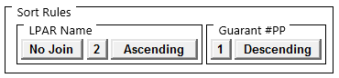

* + - In this case you could select the Key order of your choice.
* For each of these keys you could build the sort order by selecting the first and the second key by clicking on the corresponding button to switch
  + Example :

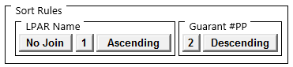

In this case the sort order is first (« **1** ») **LPAR Name** and second (« **2**») **Guarant #PP** without any join on the LPAR Name.

* + Example :

From the previous box clicking on the the « **1** » button in the **LPAR Name** key part will switch it to « **2** » and so the **Gurant #PP** key will switch to « **1** ».



In this case the sort order is first (« **1** ») **Guarant #PP** and second (« **2**») **LPAR Name**

* For each of these keys you could too select the sort order between **Ascending** and **Descending** thanks to the corresponding button.
  + In the last example :



You could see that the **LPAR Name** will be sorted in **Ascending** order and the **Guarant #PP** will be sorted in **Descending** order

# Other Features.

## Simple Dashboard.

When you hit 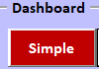 you will have a unique Dashboard display as you have in LPARDesign. This is done to figure out a single configuration.

## zPCR study generation

In this Tool, you can have multiple configurations.

So you can generate a zPCR study including those configurations (with the limitation of zPCR)

### zPCR study generation workflow.

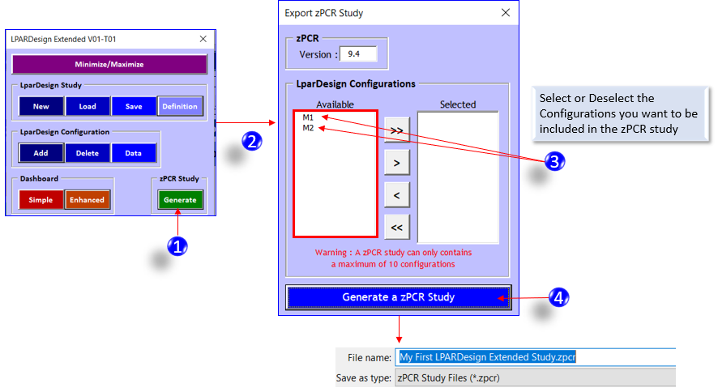

## The DATA button

 This will show you the raw values of the configurations you have loaded in the study.

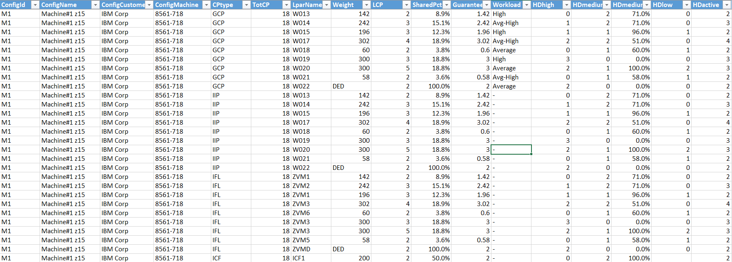

## Housekeeping

There are various buttons that helps you:

Create (new)

Restore (Load)

Save

Add (.xml Configuration)

Delete (.xml Configuration

to keep you study useful.

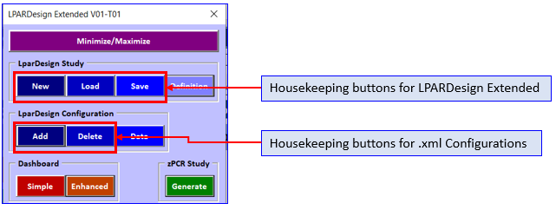



END OF DOCUMENT - Lpardesign-Extended-V02-T05_Userguide.Docx